**Smart home based on Bluetooth**

**Objective:**

Control home appliance wirelessly using mobile application via Bluetooth.

**Project description:**

Mobile application sends the data via Bluetooth that works according to the universal asynchronous receiver transmitter protocol with standard baud rate of (9600bps).By using serial peripheral interface (SPI) communication protocol the master micro-controller take the data that sent from Bluetooth and resend to the slave micro-controller. When the transmitted data received to the slave micro-controller then interrupt the system and apply the action on the home devices according to that data received, and re-send confirmation respond to master micro-controller with the devices status to display on screen (LCD).

**Fixed Data Transmit:**

1. If data =1 -----------------🡪 Device1: ON.
2. If data=2 ------------------🡪 Device2: ON.
3. If data=3 ------------------🡪 Device1:OFF.
4. If data=4 ------------------🡪 Device2:OFF.
5. If data=5 ------------------🡪 All home devices is in sleep mode.

**Layered architecture:**

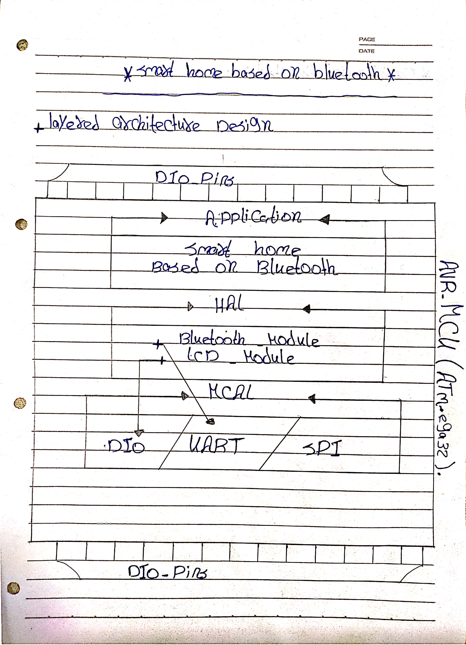

**Finite state machine of the system:**

